

**TASK**

**Exploratory Data Analysis on the High Frequency Phone Survey of Households: Ethiopia Dataset**

[](http://www.hyperiondev.com/portal/)

**Introduction**

This dataset contains harmonized variables, including basic characteristics at an Individual level for people living in Ethiopia. This dataset has been used to compare the lives of males’ vs females in different areas such as employment and literacy.

**DATA CLEANING**

In order to clean the data, the first thing that was done was drop the irrelevant columns, this dataset contains 67 columns and it was cut down to 10.

Columns were also renamed in order to make the data it contains easier to understand.

The dataset contained numerical data and in order to make it easier to read, it was converted into the written format, this was done for sex, married, form_married, disability, literacy, employed, live_alone, religion and education_level.

**MISSING DATA**

The dataset contained records with missing data which was dropped because there is a large number of records and the number of records with missing data was small in comparison. The conclusion was dropping the records with missing data would not affect the outcome of the conclusions drawn from the analysis.

**DATA STORIES AND VISUALISATIONS**

The fist few graphs look into making sure that the dataset contains a mixed number of people, this is to prove the dataset is no bias to one group or another.

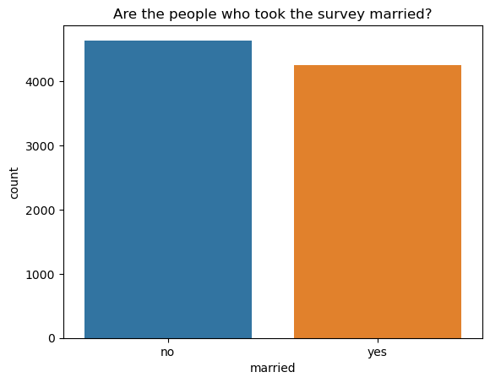

This graph looks at the number of people who took part in the survey’s marriage status, you can see there is slightly more non married people but it is mostly even.

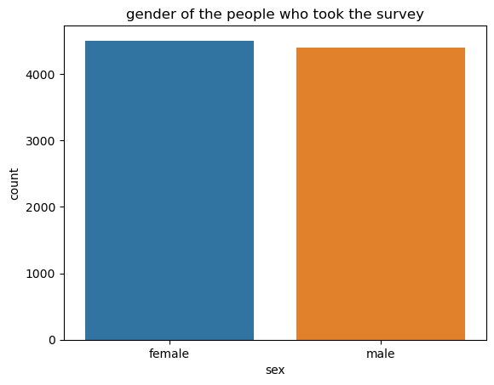

**This shows there is almost a 50/50 split of males and females, which is important for the analysis as we will be exploring male vs female lifestyles.**

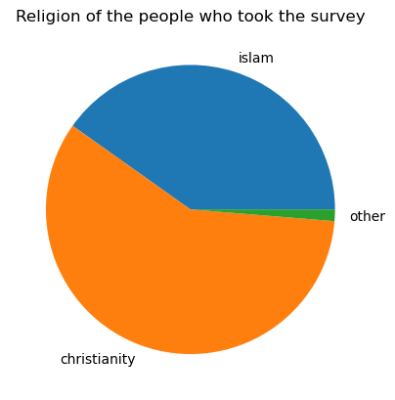

**This pie chart shows that the majority of people in Ethiopia are Christians and there are 2 main religions practised in the countries.**

**THE GRAPHS BELOW COMPARE CHARACTERISTICS FOR MALES AND FEMALES IN ETHIOPIA.**

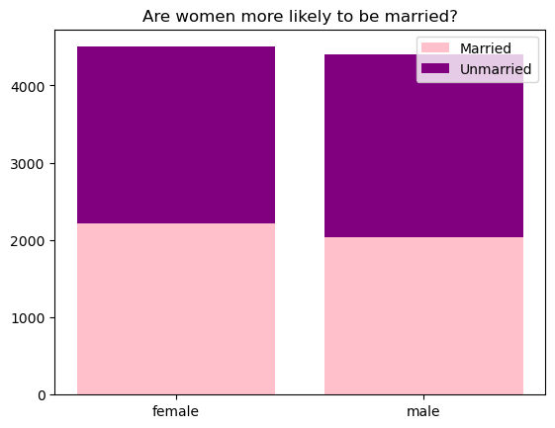

**The graph shows that women are more likely to be married than men.**

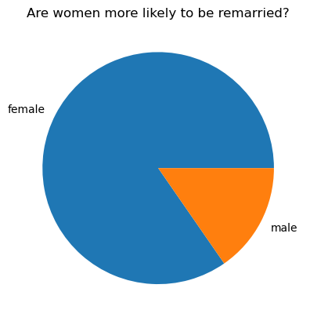

**This visualisation and the one above shows how important it is in Ethiopian culture of women to be married, as they are significantly more likely to be married more than once and there are more married women than men.**

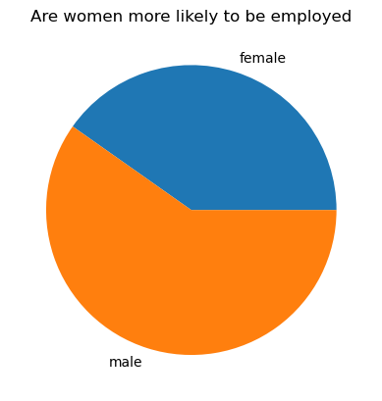

**This piechart shows that there are more men employed in the country than women. This supports the ideology which is practised in Ethiopia where men work and women are the homemakers who watch the children.**

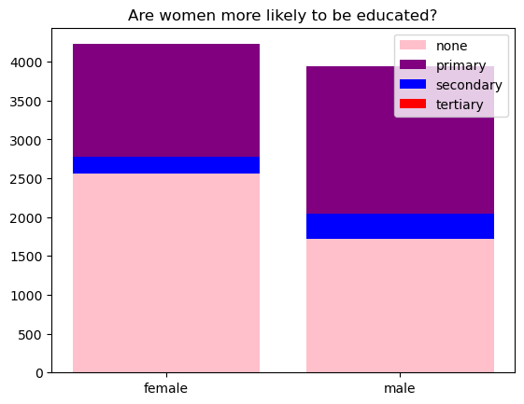

**This visualisation looks at how educated the population is, very few are educated to the highest level and you can see more males are educated at every level compared to females.**

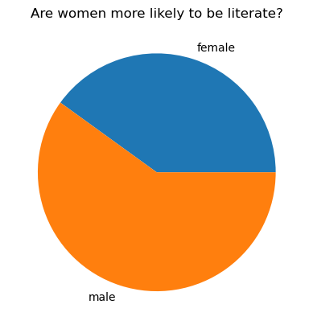

**This visualisation can be explained by the fact there are more men educated than women, and as such less women can read or write.**

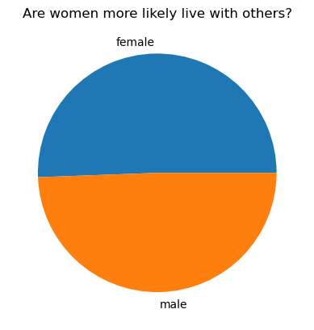

**The visualisation shows there is an even spread of people in Ethiopia who live with other people.**

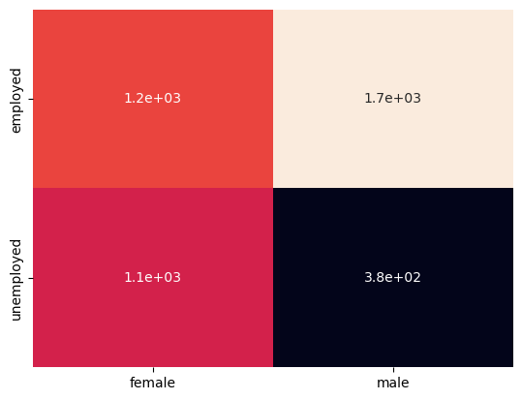

**The heatmap explores if married people are more likely to be employed. As you can see the greatest group is employed married men, this can be assumed because they have families to support and the smallest group is unemployed married men, meaning there aren’t many men who don’t support their families. The employment status of women who are married, has a smaller gap than for men which implies it is more acceptable for women to be unemployed and married.**

**THIS REPORT WAS WRITTEN BY : Sara Dimtsu**

